Barnsley Child Exploitation Screening Tool
Child exploitation is where children are being used for someone else’s advantage, gratification or profit which results in harm of the child. This incorporates both sexual and criminal exploitation. The commonality is that these activities involve manipulation, misuse, abuse, victimisation and ill-treatment. All of which are detrimental to the child’s mental health and well-being, physical health, education, social and emotional development.
Further information - Child Sexual Exploitation Child Criminal Exploitation
This Child Exploitation Screening Tool does not replace existing multi-agency safeguarding arrangements that are in place in Barnsley. If you have safeguarding and child protection concerns about a child’s welfare then you should contact the Barnsley Integrated Front Door Service to discuss.
Purpose of this screening tool
This is a screening tool that you can use to help you decide whether a child or young person may be at risk of child exploitation (CE). It is designed to be used by all professionals working with children and parents or carers. A child is defined as a person who is under 18 years of age. This tool should not be used as a blanket tool for all children, it should only be used where you have worries that a child may be vulnerable to exploitation.
This tool is intended to assist in your decision making; helping you make an initial judgement regarding the risk of child exploitation; it is neither a specialist assessment nor a referral form. The tool aims to help practitioners focus on the specific child exploitation (CE) evidence, indicators, existing safety and vulnerabilities, and determine whether further investigations are needed by Children’s Social Care or suitable for referral to the Hub or another prevention and early intervention service.
When you are considering making a referral to the Barnsley Integrated Front Door Service or sharing your concerns with the child’s allocated social worker, this screening tool should form the basis of those discussions and your professional analysis. This screening tool works best when used as a multi-agency tool and in conjunction with children and families where this is possible.
Practitioners need to exercise their own professional judgment when completing this tool because factors such as the child’s age, any additional vulnerabilities, their history etc. may mean that they are more vulnerable to CE. Professional judgment also includes capturing concerns about which you have evidence as well as concerns based ‘gut feeling’. It is important that you differentiate between the two and provide explanation and rationale. It is important to include the child’s strengths and existing safety so that this can be considered as part of the child’s ongoing safety.
No box should be left unchecked. Where you have ticked ‘yes’ there must always be evidence provided to support this (this can include untested evidence such as information from a third party, but this should clearly be identified).
Your observations of behaviours and any significant changes will be important as children will often deny or be unaware that they are being exploited.
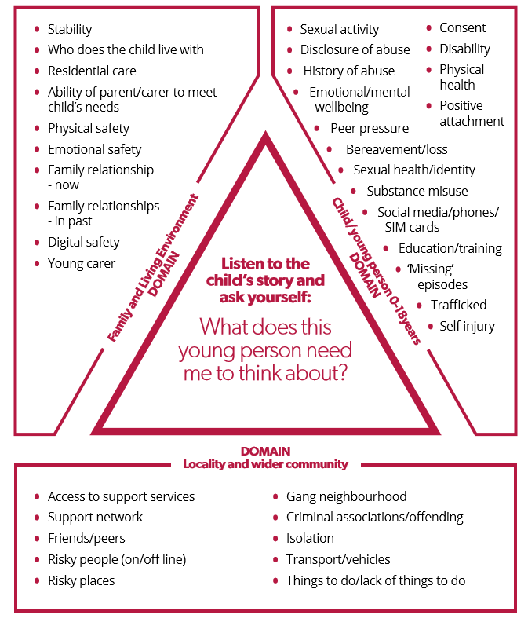

Child Exploitation Screening tool
Strong signs/indicators of Child Exploitation | Yes (please provide details and evidence) | No | Historical (over 6 months) | Unknown
- Entering / leaving vehicles driven by unknown adults
- Unexplained physical injuries and/or refusal to seek/receive medical treatment.
- Association with taxi firms/takeaway owners (night-time economy) or gang members / criminal activity / organised crime that suggest child exploitation is a possibility.
- Found travelling out of Area – no legitimate reason identified
- Multiple mobiles/changing phones frequently- or having more sim cards, receiving multiple callers or more texts/pings than usual / change of behaviour around the phone – consider what is usual phone use for a child of that age.
- Possession of hotel keys / cards or keys to unknown premises.
- Refuses/scared to enter certain geographical areas
- Expressing aggressive or intimidating views towards other groups of young people, some of whom may have been friends in the past
- Minimising or retracting statements of harm/assault made to Police / Professionals
- Driving vehicles (underage) either alone or with other young people or adults
- Information to suggest that child is involved in or has been present during a theft of motor vehicle / motorbike / scooter / quad bike
- Found with drugs concealed internally in any body part (plugging)
- Child having sex where there is coercion or where exchange / reward is involved.
- Possession with intent to supply Class A drugs
- Possession with intent to supply Cannabis or other illicit substances
- Received parcels from abroad, addressed to unknown people.
- Possession of a modified firearm
- Child refusal to engage with ANY services offered
- Multiple STIs (sexually transmitted infections) or terminations of pregnancies
- Possession of significant amount of unexplained cash (this can include unexplained money through bank transfer / Paypal etc)
- Knowledge of towns or cities child/young person has no previous connection with
Moderate signs / indicators of Child Exploitation | Yes (Please provide details and evidence) | No | Historical (over 6 months) | Unknown
- Sudden change in appearance in either direction (E.G. changes in clothing, wearing more makeup OR reduction in self-care / hygiene)
- Seems withdrawn / emotionally ‘switched off’ – from family
- Unexplained money or possessions - including high value clothing and / or jewellery, unexplained budget to access things such as taxi’s / takeaways / activities / beauty appointments etc
- Increase in aggressive behaviour / use of intimidation or threats
- Changed friendship groups and no contact with old friends
- Stays out unusually late without reason or consistently breaking parental rules
- Self-harm indicators and/or mental health concerns and/or suicidal thoughts/attempts
- Interest in music which glorifies weapons/gang culture or seems to have detailed knowledge of local criminal groups
- Using new/unknown slang words
- New nickname
- Known/suspected involvement in minor criminal activity
- Parent or close family member known/believed to be involved in crimes relating to either drugs or motor vehicle theft (either through intel or convictions)
- Concerned by the presence of unknown youths in their neighbourhoods
- Loss of interest in school, decline in attendance or achievement
- Possession of knife or other weapon – to protect/threaten
- Constantly talking about someone who seems to have a lot of influence over them
- Dropped out of positive activities
- Increased episodes of going missing and / or absconding. Parents / carers not consistently reporting the child missing
- Drug and alcohol use – Concerns for use / dependency & change / increase of use
- Starting to adopt codes of group behaviour E.G. Ways of talking and hand signs
- Unsuitable / inappropriate accommodation I.E. sofa surfing, homelessness
- Sexually transmitted infection
- Young person considered to be at risk of sexual harm on more than one occasion
- Expressions of invincibility or not caring about what happens to them
- Associating with other young people / vulnerable young adults believed/known to be at risk of exploitation
- Lack of / deterioration of positive relationships with adult/s
- Living in a chaotic / dysfunctional household
- Child/young person attending concerning locations
- Some engagement but sporadic contact, often misses appointments, limited explanation, secretive and unwilling to engage meaningfully
- Concealed / concerning use of the internet including webcam, on-line gaming (via X-box, PlayStation), chat rooms, use of social media to buy or sell Class B / C drugs
- Being accompanied to appointments by an unknown person that causes concern
Welfare / Vulnerabilities to Child Exploitation | Yes (Please provide details and evidence) | No | Historical (over 6 months) | Unknown
- Reduced time in education (consider attendance issues, reduced timetables, regular exclusions, elective home education (EHE) following any of these.
- Social isolation (lack of clear friendship group, being bullied, recently removed from education etc)
- Trauma – consider Domestic Abuse, parental drug or alcohol misuse, bereavement / family breakdown / past history of abuse (not an exhaustive list)
- Neurodivergent / speech and language difficulties / Learning difficulty / disability
- Mental Health / suicidal ideation / self-injurious behaviour
- Presenting at hospital / doctors (GP) with injuries indicative of violence (also consider reports of being ‘jumped’ and not wishing to press charges)
- Child is known to the Youth Justice Service, or has received a diversionary disposal from police
- Living in an area of increased anti-social behaviour (ASB) with peer links to this behaviour

Protective Factors | Yes | No | Historical | Unknown
Education and Learning Needs
- Enjoys and participates in learning activities
- Good links between home and school
- Planning for career and adult life
- Engaged / re-engaged in education or training, or in work
- Are there behavioural concerns in school or college
Health Needs
- Are their health needs being met
- Are their developmental milestones appropriate
- Safe and age appropriate sexual activity
- Are there concerns over misuse of drugs or alcohol
- Any physical or mental health needs identified
Emotional Health and Behaviour Needs
- Responds appropriately to boundaries and constructive guidance
- Can differentiate between safe and unsafe contacts
- Child engaged in positive activities
- Child has age appropriate and positive peers
- Good engagement with appropriate services
Family and Parenting Needs
- Parents/carers shows warm regard, praise and encouragement
- Good relationships within family, including when parents are separated
- Provides for child’s physical needs, e.g. food, drink, appropriate clothing, hygiene, medical and dental care
- Accommodation has basic amenities and appropriate facilities and can meet family needs
- Age appropriate boundaries and routines set by carer and adhered to
- Carer is aware of peer group
- Are there concerns about criminality or anti-social behaviour amongst members of the household living at the address
- Parents/carers have good engagement with appropriate services
- There is a network that is willing to engage with a safety plan for the child.

Based on the assessment above, please provide your professional opinion by ticking
ONE of the boxes below:

o No concerns of exploitation - concerns relate to behaviours associated with age-appropriate child/young person behaviours

o Evidence of vulnerability to exploitation

o Evidence of being groomed or targeted for the purposes of exploitation

o Evidence that child is being exploited

For use by the lead professional who has completed this tool: | For use by Barnsley’s Integrated Front Door:
Please provide your professional judgement and analysis of all collated information: | Please provide your professional judgement and analysis of all collated information:
Safety Planning - Please ensure that there is a safety plan in place and outline the details below: | Safety Planning - Please ensure that there is a safety plan in place and outline the details below:

