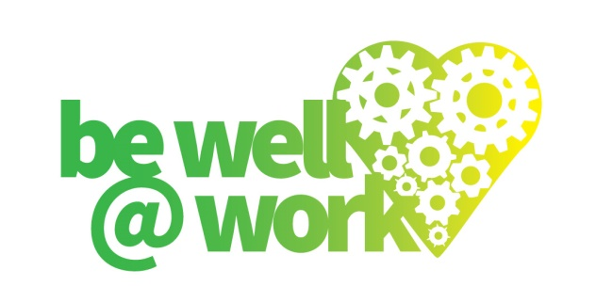

**Mental Health and Wellbeing Strategy (***insert the 3 year period that strategy refers to* **)**

**A policy for:**

**Effective from:**

**Introduction**

This strategy describes how the Company will strive to improve the mental health and wellbeing of its employees over the next three years.

This strategy aims to improve the mental health environment and culture of the company by identifying, eliminating, or minimising all harmful processes, procedures and behaviours that may cause psychological harm or illness to its employees.

The Company shall continuously strive, as far as is reasonably practicable, to promote mental health throughout the organisation by establishing and maintaining processes that enhance mental health and wellbeing.

This strategy aims to provide a pro active approach to mental health and wellbeing within the Company and will be supported by the following company policies (*add in here the range of policies )Examples below*

*Mental Health and Wellbeing Policy*

*Health and Safety Policy*

*Attendance Management Policy*

*Managing Change Policy*

*Equality and Diversity Policy*

*Flexible working and family friendly policies*

*Bullying and Harassment policy*

*Drugs and Alcohol Policy*

**Priority Areas**

1. **The Company will develop a supportive culture and address factors that may negatively affect mental health and emotional wellbeing. Stigma and discrimination will be reduced by increasing awareness and understanding of mental health. This will be achieved by :-**

* A number of mental health campaigns will be undertaken throughout the year which will be promoted through our communication channels(*include here the different methods of communications notice boards , via health champions* etc)

(*Please state how many campaigns a year will be supported and which campaigns will be supported eg World Mental Health Day, Stress Awareness Day , Mental Health Awareness Week, Time to Change, 5 Ways to Wellbeing, Anti Stigma Campaign)*

* Annually employees will be required toundertake a survey to identify mental health / emotional wellbeing needs which will be analysed and actions identified as appropriate
* Provision of a range of opportunities for employees to look after their mental wellbeing, for example through physical activities, team building days, stress reducing activities and social events.
* Provision of systems that encourage predictable working hours, reasonable workloads and flexible working practices where appropriate.
* Ensuring that all staff have clearly defined job descriptions, objectives and responsibilities and they have good line management support, appropriate training and adequate resources to do their job.
* Managers will have undertaken appropriate leadership training to be able to manage effectively, including managing conflict and ensure the workplace is free from bullying and harassment, discrimination and racism.
* Appraisals will take place on an annual basis for all staff which will include support opportunities to enhance professional development. The appraisal will include reference to the health and wellbeing of the employee.
* Mental health awareness training will be made available for all staff which includes the early identification, causes and appropriate management of mental health issues such as anxiety, depression, stress and change management. (*Add in here timescales for training of staff and refresher training)*
* A number of staff*(please state how many and in which areas eg each Department/Section or within HR/Occupational Health* ) will receive mental health first aid training by (*please add in timescales*) and in the longer term (*please state timescales*) the mental health first aid train the trainer model will be developed to help sustain roll out of the programme.
* Two way communication channels will be in place to promote this strategy -: at induction, within the employee handbook and communicated through the works forum/health and safety committee. Line Managers will provide regular updates through team meetings. During periods of organisational change support mechanisms will be offered eg retirement planning, CV writing etc
* Volunteering and out of work activities are actively encouraged. Annually employees will be permitted paid time off to participate in volunteering. The Company has a chosen charity and out of work activities will be organised and employees encouraged to participate. *Please state here the time/days permitted annually by employees to undertake volunteering/out of work activities.*

1. **The Company will provide support for employees experiencing mental health difficulties**

All employees will be informed of the support available to them through occupational health. Employees with mental health issues will be referred to the Occupational Health Nurse by their Manager. Employees may also self refer without their managers knowledge. The Occupational Health Nurse will work with the employee and their GP to ensure that the employee can access the most appropriate support.

Those employees who are off sick from work with mental health issues will be supported to return to work through a managed return to work, considering appropriate adjustments such as a phased return to work. In the event that the employee is unable to return to the same job every effort will be made to identify alternative employment within the Company which will be in consultation with the employee.

Mental health sickness will be monitored across the company *(please state how often monthly, quarterly, annually)*. Where trends/ patterns of absence in relation to mental health sickness occur these will be investigated and interventions introduced as appropriate.

1. **The Company will encourage the employment of people who have experienced mental health problems.**

The company will show a positive and enabling attitude to employees and job applicants with mental health issues and include having positive statements in recruitment literature.

All staff involved in recruitment and selection are briefed on mental health issues and the Disability Discrimination Act, and are trained in appropriate interview skills.

**Key *Performance Indicators (****add in here key performance indicators****)***

***Examples***

* *Reduction in sickness absence attributed to mental health issues*
* *Annual mental health survey and employee wellbeing survey*
* *Number of counselling/CBT referrals*
* *Retention levels*
* *No of employees receiving mental health training*
* *Engagement from employees in work based activities/volunteering*
* *Numbers attending workplace interventions*

**Monitoring and evaluation**

Senior management are responsible for the monitoring and evaluation of this strategy.

The results of the key performance indicators above will assess the impact of this strategy.

The results of the key performance indicators above will be submitted to Senior management on a (*please state period monthly, quarterly or annually*)basis.

Signed: Date: