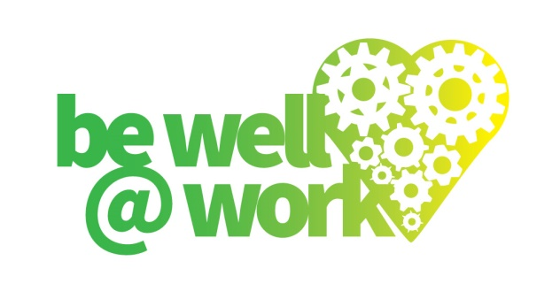

# **Workplace Smoke-free Policy**

**A smoke-free policy for:**

**Effective from:**

**Next review date:**

**Policy Statement:**

(Name of workplace) is committed to providing a healthy, comfortable and productive workplace for all its employees.

The health hazards related to smoking are well documented. These health hazards impact on both the smoker and the non-smoker who is exposed to second hand smoke. Therefore, (name of workplace) will provide a smoke-free workplace for all of its employees and visitors.

For the purpose of this Policy, the term “smoking” refers to the action of putting a cigarette, cigar, pipe, or cigarette like item etc. to the mouth; whether the item contains tobacco or not. This also includes the use of e-cigarettes.

## Vision:

(Name of workplace) has adopted this smoke-free policy for the following reasons:

* Under the Health Act 2006, all internal areas within workplaces are required to be smoke-free;
* To provide a healthy, smoke-free environment for all employees, volunteers and visitors;
* (Name of workplace) is in a position to affect positive change within the wider community;
* To become a smoke-free organisation by recognising that smoke-free settings reinforce consistent messages to the community about the harmful effects of smoking and exposure to second hand smoke;
* Under the Health Act 2006 (name of workplace) has a responsibility to protect the health of its employees from hazards including tobacco smoke exposure in the workplace.

## Purpose:

* To protect the health and safety of those who work at or visit this workplace;
* To comply with the Health Act 2006;
* To provide a smoke-free environment, buildings and grounds;
* To minimise the fire risk to (name of workplace) property attributable to cigarettes/ electronic cigarettes;
* To encourage a smoke-free workforce.

## Scope:

* This policy is applicable to all employees;
* The Smoke-free Environment component of this policy is applicable to all employees, visitors, contractors and all others accessing the organisation’s grounds and facilities. It applies to all buildings, sites, grounds, offices, cafeterias, lunch rooms and vehicles owned or occupied by (name of workplace).

## Policy: Smoke-free Environment

* All (name of workplace) sites are smoke-free;
* No smoking is permitted by staff, contractors and visitors in external areas of any site owned by the Company or controlled by them under a lease agreement. This includes entrances to buildings and offices, boundary fences and gardens;
* Should staff wish to smoke during work time, it will only be permitted during scheduled breaks.

## Promoting a smoke-free environment:

* (Name of workplace’s) Smoke-free Policy will be displayed in the staff room/ any communal areas;
* Smoke-free signs shall be displayed at all entrances to the grounds and at outer entrances to every building managed by (name of person/position);
* Contractors, visitors, volunteers and others working within (name of workplace) property will be advised of the policy and that the policy applies to them whilst on the property;
* All staff applying for positions at (name of workplace), temporary staff, volunteers and contractors will be informed of the Smoke-free Policy and made aware of the policy contents;
* (Name of workplace) Smoke-free Policy will be highlighted during staff inductions;
* Copies of the Smoke-free Policy will be made available upon request.

## Quitting smoking:

The Company will provide information on local cessation support if members of staff indicate intent to stop smoking.

Management will actively promote smoking cessation programmes and support staff and their families to quit.

## Monitoring and review:

In order to ensure fair and effective management of this Policy, arrangements will be put in place to review 6 months from implementation and annual thereafter to ensure it remains relevant.

Further advice and details of local services can be found at:

* www.yorkshiresmokefreenhs.uk
* www.nhs.uk/smokefree

Signed: Date: