1 |  | Assessment details

Date started: |  | Date complete:

(Assessment to be completed within 21 days)
Person undertaking the assessment
Name:
Position: |  | Organisation:
Email: |  | Telephone no:

Lead Professional (if not as above)
Name:
Position: |  | Organisation:
Email: |  | Telephone no:

2 |  | Family Composition and Details

Main Parent/Carer
Name: |  |  | Gender (M/F): |  |  | Ethnicity:
Address: |  |  | Postcode: |  |  | DOB:
Home Tel: |  |  | Mobile:
Relationship to children:

Parent/Carer 2
Name: |  |  | Gender (M/F): |  |  | Ethnicity:
Address: |  |  | Postcode: |  |  | DOB:
Home Tel: |  |  | Mobile:
Relationship to children:

Children
Child | Name | DOB/ EDD | Gender  (M/F) | Ethnicity | School/Nursery
1
2
3
4
5

Other adult family/household members or significant others

Name: |  |  | Gender (M/F): |  |  | Ethnicity:
Address: |  |  | Postcode: |  |  | DOB:
Home Tel: |  |  | Mobile:
Relationship to children:

Name: |  |  | Gender (M/F): |  |  | Ethnicity:
Address: |  |  | Postcode: |  |  | DOB:
Home Tel: |  |  | Mobile:
Relationship to children:

Is English the family’s 1st Language? | Yes / No
If no, please state the 1st language:
Are interpretation services required? | Yes / No

Please give details of any disabilities or special needs in the family including details of any Education health and care plan (EHCP) in place or any health and care needs assessment

Is the family registered with a GP? | Yes / No
Please give the name and address of the family GP

3 |  | Reason for undertaking this Early Help Assessment

Why is an early help assessment needed at this time?

What do you and the family hope to achieve from this assessment?
4 |  | Information sharing and storage agreement - how we will process and look after the personal data during the early help assessment and intervention.

This section must be fully completed and signed by all persons over the age of 18 present at the time of completion of the form with the family, on behalf of themselves and any child or young person for whom they are parent or carer.

We will need to collect a significant amount of personal data relating to you and any children or young people for whom you are parent or carer throughout this process from the initial early help assessment and any subsequent intervention that we establish in order that we can understand and provide the help you may need.

If we cannot cover all of your needs we may need to share some of this information with, or request additional information from other organisations such as health, education, private and voluntary agencies and support services so that they can help us to understand your needs and to provide you with the services you need. We will notify you in advance of any third party involvement.

Please be assured that this information along with any information gathered throughout the lifetime of any intervention offered will be stored securely either within a secure electronic recording system or locked in a secure filing system in line with the agency undertaking the assessment/intervention/role of lead professional’s policies and procedures – specific information can be made available on request.

The information recorded within the early help assessment and intervention such as the assessment, action plans and notification of closure will be shared with and recorded by Barnsley Council in their role of co-ordination and monitoring of early help assessments and interventions. Barnsley Council’s privacy statement is available to view at www.barnsley.gov.uk/privacy.

Personal information will be treated as highly confidential and will not be shared without your permission for any other reason unless we are required by law to share it or unless you or anyone else will come to some harm if we do not share it. In any case we will only ever share the minimum information we need to share.

The early help assessment and intervention are voluntary and you have the right to withdraw from the process at any time. If you do choose to withdraw then you should inform the lead professional either verbally or in writing.

I understand the information gathered and recorded as part of the early help assessment and any subsequent intervention will be stored and used for the purpose of providing services to myself and the children or young people for whom I am parent or carer

I have had the reasons for information sharing and information storage explained to me and I understand those reasons and give my agreement to share and request information in the relevant circumstances

I understand that the information provided on this form relating to myself and others will be recorded and that they may be contacted as part of the assessment and intervention

I understand that the information that is gathered and recorded as part of the early help assessment and any subsequent intervention may be used by Barnsley Council for local and national monitoring and reporting purposes.

Signatures of persons present
Signed: |  | Name: |  | Date:
Signed: |  | Name: |  | Date:
Signed: |  | Name: |  | Date:

Professionals Signature
Signed: |  | Date:

5 |  | Previous Support Service or Other Agency Involvement

Is there, or has there been any previous support service or agency involvement for any member of the family? Agencies involved should be contacted following agreement with the family. | Yes No

If yes please give brief details:

Family Member | Service/Agency | Name and role of any key worker/professional | Contact details | Approx start and end dates | Reason for involvement/ details of assessments undertaken

6 |  | Child Assessment – Please identify any Strengths/Needs for every child or young person within the household /who is part of the early help assessment and consider what life is like for the child.

 |  | CHILD 1 |  | CHILD 2 | CHILD 3 | CHILD 4
NAME
ALIAS NAMES (any others used)
Age
Development of unborn baby, infant, child or young person.
Health.  (Consider health, growth & developmental, lifestyle concerns; diet; disability; access to GP, dentist, optician, immunisations, child health programme; A&E attendances; teenage health advice and promotion; speech and language skills; attendance at appointments; | Strengths  (what is going well)
Needs
(outstanding health needs)
Identity, Emotional and Behavioural development.  (Consider Positive attachment; confidence; positive attitude to relationships/friendships; generally happy; self control; Impulsivity; alcohol /substance misuse; sexual behaviour; positive self image; social presentation; sense of belonging; vulnerability, bullying; discrimination; sexual exploitation offending behaviour; positive choices;  Self harm; copes with stress; perception of self; knowledge of family history; aggression; religion. | STRENGTHS  (what is going well)
NEEDS
(What is not going as well)
Education and learning

(Consider- reasoning; communication; listening and understanding  access to toys and resources; regular attendance at early years/school; play and interaction; problem solving; imagination; attitude and progress in learning; plans and aspirations; additional support; transition; concentration/attention; easily distracted; strengths and talents; post-16 planning; | STRENGTHS  (what is working well)
NEEDS
(what is not working as well)
Family and social relationships.  (Consider- Consistent parenting; close and loving relationship with parent/carer; confident of parental and wider family support; helpful and caring; supportive of siblings and peers; access to positive role models; is the child a young carer; stable home environment; domestic abuse; harassment or social isolation due to ethnicity/gender. | STRENGTHS  (what is working well)
NEEDS
What is not working as well)
Social presentation and self care skills.  (Consider- personal hygiene; appropriate clothing and dress; independent living skills; positive separation from family; identifies with peer group; access to school uniform; additional needs due to disability. | STRENGTHS  (what’s working well)
NEEDS
(what’s not working as well)

7 |  | Adult Assessment – Please identify any Strengths and Needs for every adult who is part of the household/early help assessment

 |  | ADULT 1 | ADULT 2 | ADULT 3 | ADULT 4
NAME
ALIAS NAMES (any others used)
Family & environmental factors
Family Social Integration.  (Consider family functioning & relationships in the home and home stability; chronic illness/disability; physical, emotional and mental health needs; domestic abuse; bereavement; pregnancy; antenatal care and readiness for baby; harassment/exploitation; substance and/ or alcohol misuse; offending; antisocial behaviour; social isolation; access to services.) | STRENGTHS  (what works well)
NEEDS
(what’s not working as well)
Wider family. (Consider formal and informal support networks from extended family; cultural/religious needs ) | STRENGTHS  (what works well)
NEEDS
(what’s not working as well)
Employment, training and finance. (Consider work arrangements; access to employment and training; family access to a living wage; access to adult literacy and numeracy; benefit entitlements. | STRENGTHS  (what works well)
NEEDS
(what’s not working as well)
Housing. (Consider home conditions; local environment; rent arrears; overcrowding; threat of homelessness. | STRENGTHS  (what works well)
NEEDS
(what’s not working as well)
Parenting and Basic Care Skills
Ensuring basic care and safety. (Consider ability to provide warmth, appropriate diet; a safe home; appropriate clothing; ensure that all medical and dental needs are met; protect from danger and witnessing any form of abuse or violence or substance/alcohol misuse. | STRENGTHS  (what works well)
NEEDS
(what’s not working as well)
Emotional warmth & positive parenting.  (Consider - demonstrates affection and love; supportive praise and encouragement; supportive of development through interaction and play, celebrates success; shows awareness and understanding of individual child’s abilities and development; encourages learning; provides opportunities; actively involved in supporting child’s education; responds appropriately to child’s emotions; | STRENGTHS  (what works well)
NEEDS
(what’s not working as well)
Guidance, boundaries and stability.  (Consider whether parents/carers model appropriate behaviour; effective and appropriate discipline; encourage self control; give appropriate explanations; offer a consistent routine; ensure regular school attendance; encourages appropriate friendships | STRENGTHS  (what works well)
NEEDS
(what’s not working as well)

8 |  | Family comments and voice

Please ensure that you capture the voice of the whole family using the areas below and the Helping Us to Help You resources available at www.barnsley.gov.uk/earlyhelp which include forms designed for use with children and young people.

To help us to understand where you and your family are in your journey of change and to help us work out what needs to happen next to improve things for your family, please think about the statements below taking in to account your families current strengths and areas of need and let us know which statement you feel best describes where you are currently at:

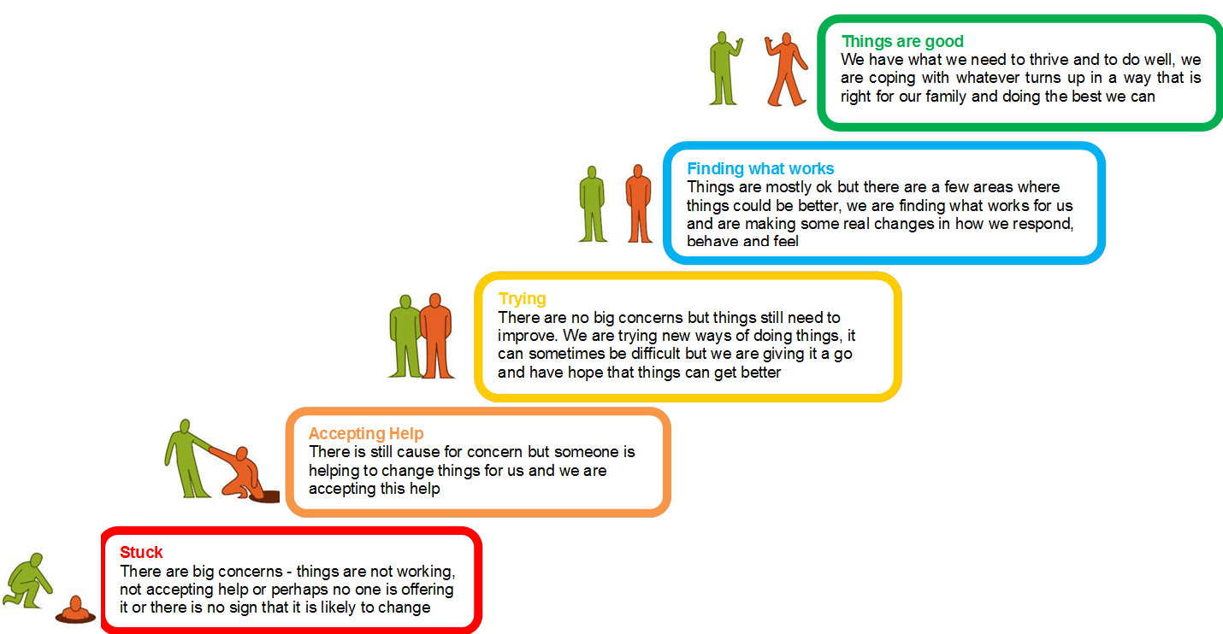

:

What do you want to change?

What do you hope will happen?

How will we know it’s working/worked?

Family Member | Comments

9 |  | Family Impact Analysis – An Overview

Please explain the impact of the issues identified in the adult and child assessments on the functioning of the family and the development and wellbeing of family members considering:

- Health | - Education attendance, behaviour and achievement | - Employability | - Children’s general well-being and basic care
- Parental guidance, boundaries and stimulation | - Family functioning and well-being | - Formal and informal support networks from extended family and others | - Local services, social networks and community

10 |  | Family Conclusions, Solutions and Actions

Please tick (or place an X) next to the Categories of Need which have been identified.

Category | Identified? | Category | Identified? | Category | Identified?
Anti-social behaviour |  | Health need - child |  | School exclusion
Attendance |  | Lack of progress made |  | Sexual health
Bereavement |  | Mental health – child |  | Social isolation
Child Sexual Exploitation |  | Mental health – adult |  | Step down from social care
Child Disability |  | Neglect |  | Step down from specialist intervention
Child emotional wellbeing |  | Offending – child |  | Substance use - Child
Child learning needs |  | Offending - adult |  | Substance use - Adult
Domestic abuse |  | Parent disability |  | Teenage pregnancy
Existing CAF transferred to EHA |  | Parent emotional wellbeing |  | Tenancy
Family breakdown |  | Parenting skills need |  | Young Carer
Family relationships |  | Peer relationships |  | Other (please state below):
Financial exclusion |  | Poor housing conditions
Health need - adult |  | Recommended by social care

Please consider whether the Think Family criteria are met (where the family have at least two of the following identified needs).

Criteria | Need Identified?
Parents and Children involved in crime or anti-social behaviour in the previous 12 months
Children who have not been attending school regularly (less than 90% attendance, 3 or more exclusions) across the last 3 consecutive terms
Children who need early help
Adults out of work or at risk of financial exclusion or young people at risk of worklessness or NEET
Families affected by Domestic Violence and abuse in the last 12 months(includes police call outs for domestic violence)
Parents and Children with a range of health problems (Mental Health, Substance Misuse)

Addressing which of these needs will have the greatest impact on the family members and their circumstances? These will be used in your first team around the family (TAF) meeting to set desired outcomes and action
11

1
2
3
4
5
12 |  |  | What happens next?

Using the information gathered throughout this assessment and needs identified identify below the most appropriate response to ensure that the families’ needs are responded to in the most appropriate ways to ensure that they receive the right support at the right time

If you are concerned that an infant, child or young person has been harmed or abused or is at risk of being harmed or abused, you must follow your Local Safeguarding Children Board (LSCB) safeguarding children procedures. The practice guidance What to do If you’re worried a child is being abused (HM Government, 2015) sets out the processes to be followed by all practitioners.

If you think the child may be a child in need (under section 17 of the Children Act 1989) then you should also consider referring the child to children's social care. These referral processes will be included in your local safeguarding children procedures and are set out Working Together to Safeguard Children (2015). You should inform the child and family before making such a referral unless to do so would place the child at increased risk of significant harm.

Please tick (or place an X) one of the following assessment outcomes with a brief explanation and details of follow-up referrals made where requested.

 |  |  | Details of follow-up
Recommended support | Please tick | Explanation | Service details | Named contact | Date
Family needs are to be met by single agency response with a clear action plan – no TAF required
Multiagency support - Form a Team Around the Family and arrange an initial meeting to agree the action plan
Assessment to be used to inform request for support from tier two/three services/agencies
Assessment to be used to support Social Care Request for Service

Where a need to establish a team around the family (TAF) has been identified:

Proposed TAF members/agencies:
Agency | Suggested role/name of person

Planned date, time and venue of Team Around the Family (TAF) meeting

13 |  | Once you have completed the Early Help Assessment

- Once the EHA has been established:

Scan and email the completed EHA to Earlyhelp@barnsley.gov.uk.

- If the desired outcomes have not been met and the EHA closed within 18 weeks:

Scan and email the most recent action plan to Earlyhelp@barnsley.gov.uk at 18 weeks for review to assess progress, timescales and next steps.

- When the EHA has closed:

Complete, scan and email closure reporting form documents to
Earlyhelp@barnsley.gov.uk

Please note it is your responsibly to ensure that these forms are emailed securely. If you require support with this then please email us to discuss this before sending in any sensitive information.

