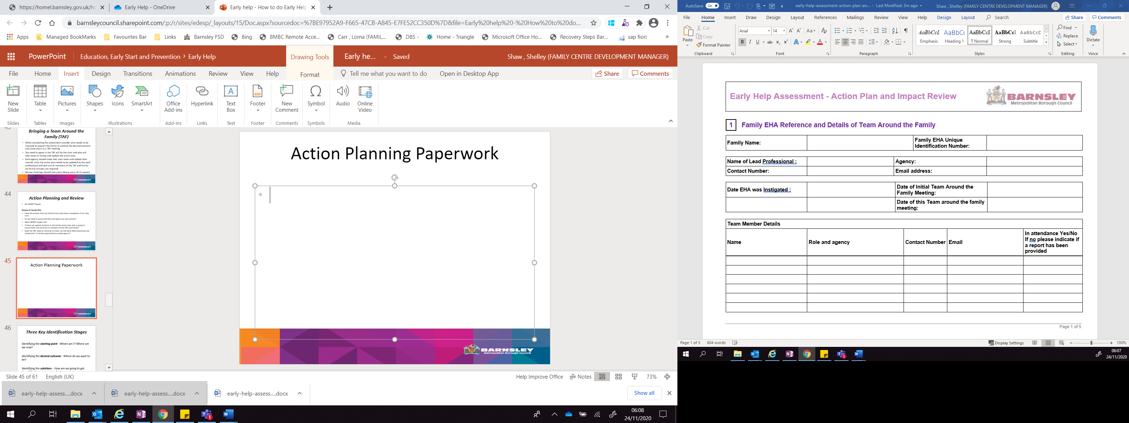

Family Name: |  | Family Group Number

Name of Lead Professional : |  | Agency:
Contact Number: |  | Email address:

Date EHA was Instigated : |  | Date of Initial Team Around the Family Meeting:
 |  | Date of this Team around the family meeting:

Team Member Details
Name | Role and agency | Contact Number | Email | In attendance Yes/No  If no please indicate if a report has been provided

2 |  | Action Plan to address the needs identified as having the greatest impact (to be reviewed and updated at every meeting)

NEED 1: |  | Desired outcome for the family:

What is to be done? | Who will do it?  (Name & Agency) | When By | Desired/measurable outcome | Progress on Action | Impact on Desired Outcome  (include any identified barriers)

NEED 2: |  | Desired outcome for the family:

What is to be done? | Who will do it?  (Name & Agency) | When By | Desired/measurable outcome | Progress on Action | Impact on Desired Outcome  (include any identified barriers)

NEED 3: |  | Desired outcome for the family:

What is to be done? | Who will do it?  (Name & Agency) | When By | Desired/measurable outcome | Progress on Action | Impact on Desired Outcome  (include any identified barriers)

NEED 4: |  | Desired outcome for the family:

What is to be done? | Who will do it?  (Name & Agency) | When By | Desired/measurable outcome | Progress on Action | Impact on Desired Outcome  (include any identified barriers)

NEED 5: |  | Desired outcome for the family:

What is to be done? | Who will do it?  (Name & Agency) | When By | Desired/measurable outcome | Progress on Action | Impact on Desired Outcome  (include any identified barriers)

NEED 6: |  | Desired outcome for the family:

What is to be done? | Who will do it?  (Name & Agency) | When By | Desired/measurable outcome | Progress on Action | Impact on Desired Outcome  (include any identified barriers)

5 |  | Family Voice

Please ensure that you capture the voice of the whole family using the feedback area below and the Helping Us to Help You resources available at www.barnsley.gov.uk/earlyhelp which include feedback forms designed for use with children and young people.

Family Early Help Assessment Feedback
The Early Help Assessment is here to help when you need extra support with your family. It should allow you and the workers involved with your child/family a shared understanding of needs. The early help assessment and intervention is about supporting you and your family to find what works and achieve your goals/desired outcomes. It should also help us to share information and mean that you should not have to repeat your information lots of times. We want to find out how well we are doing using the Early Help Assessment and intervention to support you and your family.

 | Yes | Not Sure | No
We discuss the needs of my family in the TAF meeting and I am asked what I think
We talk about all aspects of my family’s life - what is going well as well as the problems
We have agreed a plan of action that I think will improve things for my child/ren and our family
We agree who the information can be shared with
We receive the help we need
Having an Early Help Assessment is making a difference
Please tell us anything else you think we need to know:

To help us to understand where you and your family are in your journey of change and to help us work out what needs to happen next to improve things for your family, please think about the statements below taking in to account your families current strengths and areas of need and let us know which statement you feel best describes where you are currently at:

