**2024 0112 – PROW response**

Please see below our comments regarding the above

Public Footpaths Wombwell 17 and 18 are within the red line boundary.

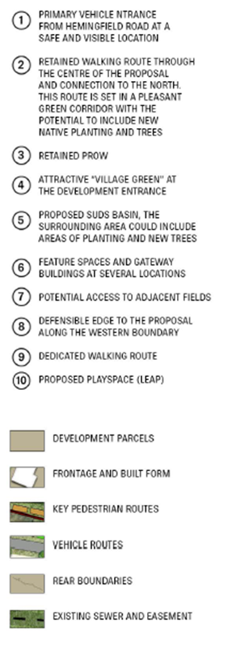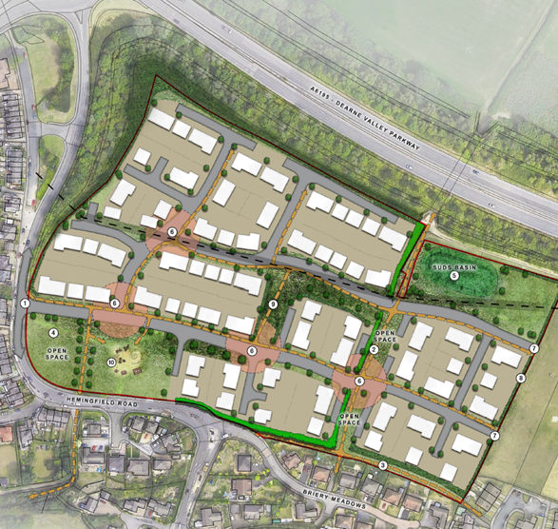

Public Footpaths 17 and 18 will potentially be affected by the proposed development. Please see below an extract from our online definitive map. Footpath 18 runs along the southern boundary (labelled 3 on the above masterplan from 2023 ENQ 00437). The alignment of these footpaths should not be moved. If the public footpath alignment needs to change, they can only be moved via a formal legal order, which is a separate process to planning and is subject to separate requirements, public consultations and costs. The path cannot be lawfully moved without the correct permissions, regardless of planning status. This can be a lengthy process and an application should be submitted as soon as the layout is established to prevent possible delays to development. I have attached the relevant application form and guidance notes for information, which give details on costs and likely timeframes. Please include the below informatives regarding Public Path Orders which cover changed to footpath alignments through the process of a diversion order.

The footpaths crossing the site should remain open as often as possible during construction. However, a temporary closure order will also be required, at cost, during any periods when either of the public footpaths are closed for safety reasons during construction. We request that footpath 18 be kept open and available for public use of long as possible. Please see below the informatives regarding temporary closure orders.

Who will be responsible for the maintenance of the proposed walking routes through the site, marked in dashed orange on the above plan? As these and not recorded Public Rights of Way, BMBC will not be responsible for the maintenance and upkeep of these routes.

The plan shows the roads/access marked 7 on the above plan potentially going into the adjacent open fields. Have the owners of the adjacent field given permission and where will these routes go?

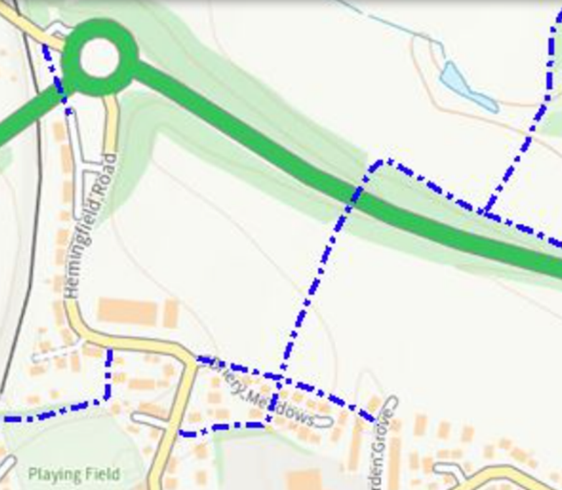

It has also been noted that there appear to be a number of new pedestrian routes proposed as part of the development, please see the informative below.

If the application is accepted, please add the following informative:

Informatives

*PPO required - The proposed development will require the diversion of one or more public rights of way. Any changes to public rights of way are subject to a separate legal process and public consultations, which must be confirmed before any works take place. Planning permission does not grant permission to build over public rights of way unless this legal process has been satisfied. The Council’s Public Rights of Way department should be contacted to discuss the proposals and an application should be submitted as early as possible to minimise the risk of delays to development. For more information contact publicrightsofway@barnsley.gov.uk.*

*TCO required - The proposed works will require a temporary closure of a public right of way. The developer is required to apply for the temporary closure, at cost, providing at least 4 weeks’ notice and details of how public access will be managed throughout. No works affecting a public right of way may take place until a temporary closure order has been agreed in writing with the Council. Details are available via publicrightsofway@barnsley.gov.uk.*

No building or use hereby permitted shall be occupied until details of arrangements for the future management and maintenance of proposed carriageways, footways, footpaths and landscaped areas not put forward for adoption as maintainable at public expense within the site have been submitted to and approved in writing by the LPA. On occupation of the first dwelling (or building) within the site, the streets shall be maintained in accordance with the approved management and maintenance details.

**Reason: To ensure that all private streets and landscaped areas are appropriately managed and maintained to ensure the safety of all users in accordance with Local Plan Policy T4**