Barnsley Education Inclusion Specialist Support Services
Barnsley Portage Service
Request for Involvement


https://www.barnsley.gov.uk/services/schools-and-education/barnsley-education-inclusion-services/portage-service/

Portage Service work directly with parents/carers of children up to 4 years of age with significant developmental delay, to support continued development through play in the family home.

Our Request for Involvement form needs to be completed in full for it to be processed
Before completing the request for involvement please check that the following criteria have been met:

- The ‘Portage Request for Involvement flowchart’ (see Portage Service webpage for document) has been used to inform decision making in relation to requesting Portage involvement. Link to Barnsley Portage Service webpage

- The child’s developmental stage has been considered against the ‘Overview of Early Years Developmental Progress Tool’ (see Portage Service webpage for document) and their development has been assessed as 50% delay in at least one area of development. Link to Barnsley Portage Service webpage

- The request for involvement has been discussed, completed and agreed with parent(s)/carer(s).

- The child’s parent(s)/carer(s) has agreed that they will be able to commit to regular Portage sessions in the family home with their child and the Portage worker.
Requester’s Details
Name:  Email address:  Phone contact: | Role:  Service:

I confirm that this request for involvement has been discussed and agreed with parents/carers

Signature: Date:

Parents/Carers Names: | Parents/Carers email address:  Parents/Carers phone contact:
Language spoken at home: | Parents/Carers preferred spoken language:
Child’s details
Surname: | Forename: | Date of Birth: | Gender:

Address

Early Help Assessment (EHA):  Yes or No: | Looked after child (LAC):  Yes or No: | Social Care Involvement: Child In Need (CIN) Child Protection (CP)  Yes or No: CIN, CP or N/A:
Additional Information
Summary of developmental stage
Please complete the grid below with parents/carers, using the ‘Overview of Early Years Developmental Progress Tool’ document.

 | Date of assessment | Chronological Age | Developmental Stage
Communication and Language |  |  | Choose an item.
Cognition and Learning |  |  | Choose an item.
Physical Development |  |  | Choose an item.
Personal Social and Emotional Development |  |  | Choose an item.

Relevant information including diagnosis and/or identified health need.

Parent(s)/Carer(s) name(s) | Parent’s/Carer’s  (person with parental responsibility) | Date
I agree to my child having direct involvement with the Portage Service and understand that BMBC will not collect any information that is not needed to provide and oversee this service. I agree that any relevant information will be shared with appropriate professionals such as other BMBC services and Health professionals and that BMBC will not share my information with anyone else without my consent. | *Sign in this box if you agree*
I give my permission for BMBC to retain and process this information for the purpose outlined above, as without this BMBC cannot provide this service. I am aware that I can withdraw consent at any time. If I decide that I no longer wish for the service to be involved, I will contact the Inclusion Service at adminintegratedinclusionservices@barnsley.gov.uk so that they can remove my child’s details from their records. | *Sign in this box if you agree*

Please indicate agencies involved with the family and attach any relevant reports/letters to this request

Service/Practitioner | Name and Contact or N/A | Service/Role | Name and Contact or N/A
Health Visitor |  | Physiotherapy
Child Development Practitioner |  | Speech and Language Therapy
Paediatrician |  | Occupational Therapy
Consultant |  | Hearing Support
Social Care |  | Vision Support
Early Help |  | Family Hubs

Ensure the form is completed in full before returning to the address or email below.
Receipt of the Request for Involvement will be acknowledged via email to the referrer.
PO Box 634, Barnsley, S70 9GG
Portage@barnsley.gov.uk
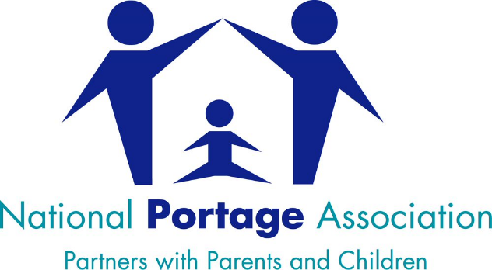
Barnsley Portage Service registered with the National Portage association

